Ex.no:8 | MINI PROJECT – FINANCE / BANKING DATA ANALYTICS

Aim:
To clean, transform, and analyze financial transaction data using Python, Power BI, and Tableau to derive meaningful insights into transaction trends, transaction types, account types, merchants, transaction status, and customer activity.
Algorithm:
- Load the financial transaction dataset from the CSV file using Pandas.
- Inspect the dataset for its structure, data types, missing values, and duplicate records.
- Clean the dataset by removing duplicate records and standardizing column names.
- Convert the transaction date into a proper date format.
- Standardize categorical values such as account type, transaction type, merchant, currency, and transaction status.
- Create derived fields such as year, month, month name, and year-month for time-based analysis.
- Analyze key financial metrics such as total transactions, total transaction amount, average transaction amount, and total customers.
- Analyze transactions based on transaction type, transaction status, account type, and merchant.
- Create interactive dashboards and visualizations using Power BI and Tableau.
- Generate meaningful insights from the financial transaction analysis.
- End the process.
Architecture:

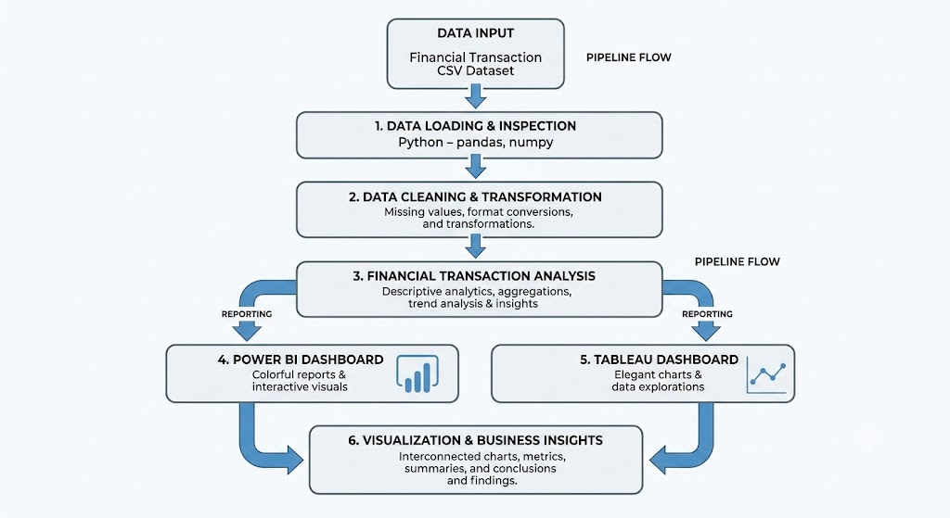
Program:
1. Python – Data Loading, Inspection and Cleaning
import pandas as pd
# Load dataset
df = pd.read_csv("/content/Financial_Transactions_Clean.csv")
# Create a copy for processing
finance = df.copy()
print("First 5 Records:")
display(finance.head())
print("\nDataset Shape:")
print(finance.shape)
print("\nColumn Names:")
print(finance.columns.tolist())
print("\nData Types:")
print(finance.dtypes)
print("\nMissing Values:")
print(finance.isnull().sum())
print("\nDuplicate Records:")
print(finance.duplicated().sum())
# Create another copy for cleaning
bank = finance.copy()
# Standardize column names
bank.columns = (
bank.columns
.str.lower()
.str.strip()
.str.replace(" ", "_")
)
# Remove duplicate records
before = bank.shape[0]
bank.drop_duplicates(inplace=True)
after = bank.shape[0]
print("Duplicates removed:", before - after)
print("\nMissing Values After Cleaning:")
print(bank.isnull().sum())
print("\nCleaned Dataset Shape:")
print(bank.shape)
print("\nCleaned Column Names:")
print(bank.columns.tolist())
print("\nFirst 5 Cleaned Records:")
display(bank.head())

2. Python – Financial Transaction Analysis
# Total number of transactions
total_transactions = bank["transaction_id"].nunique()
# Total transaction amount
total_amount = bank["amount"].sum()
# Average transaction amount
average_amount = bank["amount"].mean()
# Total customers
total_customers = bank["customer_id"].nunique()
# Credit transactions
credit_transactions = (
bank[bank["transaction_type"].str.lower() == "credit"]
["transaction_id"].nunique()
)
# Debit transactions
debit_transactions = (
bank[bank["transaction_type"].str.lower() == "debit"]
["transaction_id"].nunique()
)
# Completed transactions
completed_transactions = (
bank[bank["transaction_status"].str.lower() == "completed"]
["transaction_id"].nunique()
)
# Failed transactions
failed_transactions = (
bank[bank["transaction_status"].str.lower() == "failed"]
["transaction_id"].nunique()
)
print("========== FINANCIAL ANALYTICS SUMMARY ==========")
print("Total Transactions :", total_transactions)
print("Total Transaction Amount :", round(total_amount, 2))
print("Average Transaction :", round(average_amount, 2))
print("Total Customers :", total_customers)
print("\nTransaction Type:")
print("Credit Transactions :", credit_transactions)
print("Debit Transactions :", debit_transactions)
print("\nTransaction Status:")
print("Completed Transactions :", completed_transactions)
print("Failed Transactions :", failed_transactions)

3. Python – Standardization of Categorical Values
# Columns containing text/category values
categorical_columns = [
"account_type",
"transaction_type",
"currency",
"merchant",
"transaction_status"
]
# Standardize text values
for col in categorical_columns:
bank[col] = (
bank[col]
.astype(str)
.str.strip()
.str.lower()
.str.title()
)
print("Account Types:")
print(bank["account_type"].value_counts())
print("\nTransaction Types:")
print(bank["transaction_type"].value_counts())
print("\nTransaction Status:")
print(bank["transaction_status"].value_counts())
print("\nMerchants:")
print(bank["merchant"].value_counts())

4. Python – Account Type Analysis
account_analysis = bank.groupby("account_type").agg(
Transactions=("transaction_id", "nunique"),
Total_Amount=("amount", "sum"),
Average_Amount=("amount", "mean")
).reset_index()
print("Account Type Analysis:")
display(account_analysis)

5. Python – Merchant Analysis
merchant_analysis = bank.groupby("merchant").agg(
Transactions=("transaction_id", "nunique"),
Total_Amount=("amount", "sum"),
Average_Amount=("amount", "mean")
).reset_index()
print("Merchant Analysis:")
display(merchant_analysis)

6. Python – Monthly Transaction Analysis
# Convert transaction date to datetime
bank["transaction_date"] = pd.to_datetime(bank["transaction_date"])
# Create Year-Month column
bank["year_month"] = (
bank["transaction_date"]
.dt.to_period("M")
.astype(str)
)
monthly_analysis = bank.groupby("year_month").agg(
Transactions=("transaction_id", "nunique"),
Total_Amount=("amount", "sum"),
Average_Amount=("amount", "mean")
).reset_index()
print("Monthly Transaction Analysis:")
display(monthly_analysis)

7. Python – Data Visualization
Credit vs Debit Transactions
import matplotlib.pyplot as plt
transaction_type = (
bank.groupby("transaction_type")["transaction_id"]
.nunique()
)
transaction_type.plot(kind="bar")
plt.title("Credit vs Debit Transactions")
plt.xlabel("Transaction Type")
plt.ylabel("Number of Transactions")
plt.xticks(rotation=0)
plt.show()
Transaction Amount by Merchant
merchant_amount = (
bank.groupby("merchant")["amount"]
.sum()
.sort_values(ascending=False)
)
merchant_amount.plot(kind="bar")
plt.title("Transaction Amount by Merchant")
plt.xlabel("Merchant")
plt.ylabel("Total Transaction Amount")
plt.xticks(rotation=45)
plt.show()
Transaction Amount by Account Type
account_amount = bank.groupby("account_type")["amount"].sum()
account_amount.plot(kind="pie", autopct="%1.1f%%")
plt.title("Transaction Amount by Account Type")
plt.ylabel("")
plt.show()
Monthly Transaction Amount Trend
monthly_amount = bank.groupby("year_month")["amount"].sum()
monthly_amount.plot(kind="line", marker="o")
plt.title("Monthly Transaction Amount Trend")
plt.xlabel("Month")
plt.ylabel("Total Transaction Amount")
plt.xticks(rotation=45)
plt.show()

8. Power BI – DAX Measures
Total Transactions
Total Transactions =
DISTINCTCOUNT(
'Financial_Transactions_Clean (1)'[transaction_id]
)
Total Transaction Amount
Total Transaction Amount =
SUM(
'Financial_Transactions_Clean (1)'[amount]
)
Average Transaction Amount
Average Transaction Amount =
AVERAGE(
'Financial_Transactions_Clean (1)'[amount]
)
Total Customers
Total Customers =
DISTINCTCOUNT(
'Financial_Transactions_Clean (1)'[customer_id]
)
Credit Transactions
Credit Transactions =
CALCULATE(
[Total Transactions],
'Financial_Transactions_Clean (1)'[transaction_type] = "Credit"
)
Debit Transactions
Debit Transactions =
CALCULATE(
[Total Transactions],
'Financial_Transactions_Clean (1)'[transaction_type] = "Debit"
)
Completed Transactions
Completed Transactions =
CALCULATE(
[Total Transactions],
'Financial_Transactions_Clean (1)'[transaction_status] = "Completed"
)
Failed Transactions
Failed Transactions =
CALCULATE(
[Total Transactions],
'Financial_Transactions_Clean (1)'[transaction_status] = "Failed"
)
Completion Rate
Completion Rate =
DIVIDE(
[Completed Transactions],
[Total Transactions],
0
)

9. Power BI Dashboard
The Power BI dashboard was created using the cleaned financial transaction dataset.
The following visualizations were created:
- Total Transactions
- Total Transaction Amount
- Average Transaction Amount
- Total Customers
- Credit vs Debit Transactions
- Transaction Amount by Merchant
- Transaction Amount by Account Type
- Monthly Transaction Amount Trend
- Transaction Status Analysis
- Account Type, Transaction Status, and Transaction Type slicers

Output:
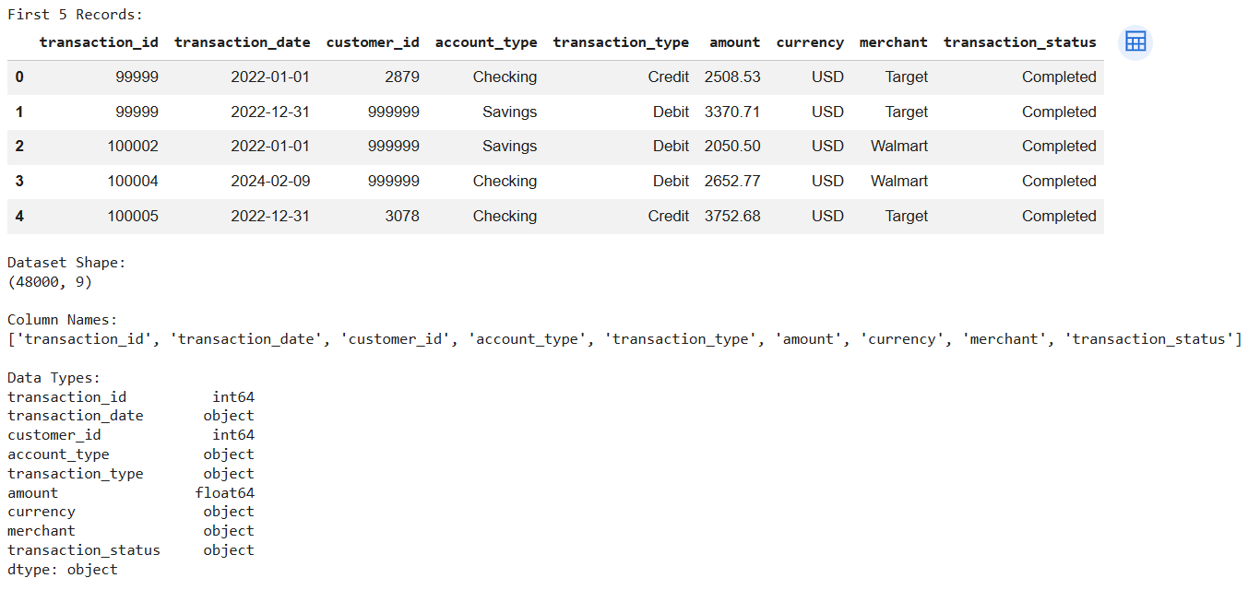
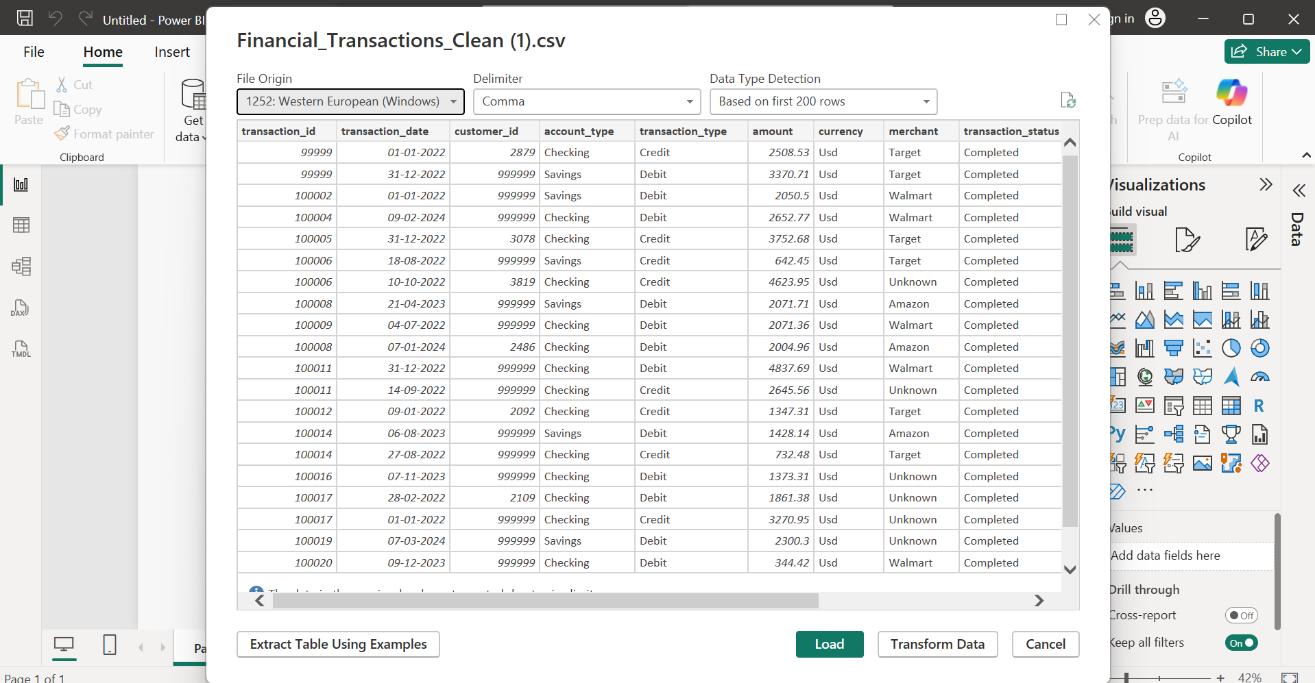
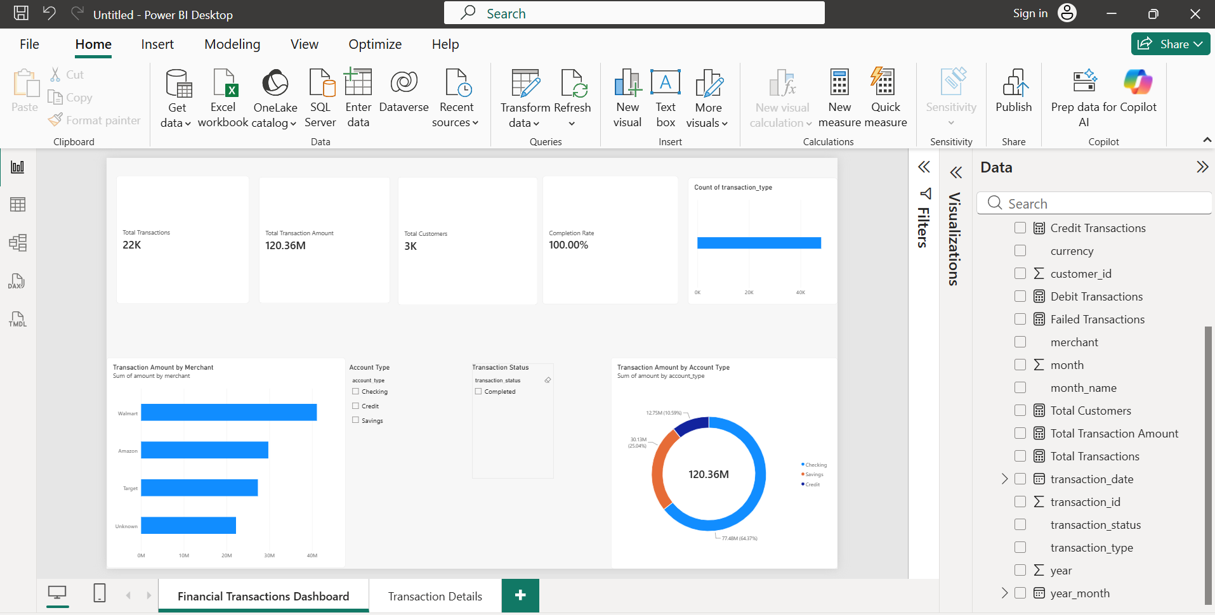
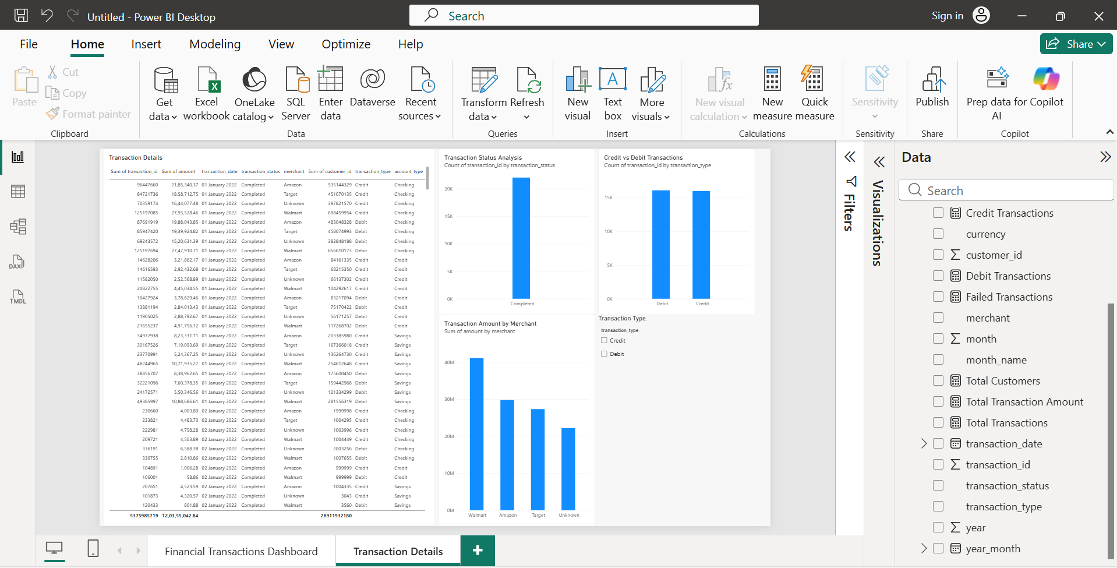
10. Tableau Dashboard
The cleaned financial transaction dataset was connected to Tableau and separate worksheets were created for financial analysis.
The following visualizations were created:
- Credit vs Debit Transactions
- Transaction Amount by Merchant
- Transaction Amount by Account Type
- Monthly Transaction Amount Trend
The worksheets were used to create the Tableau dashboard.

Output:
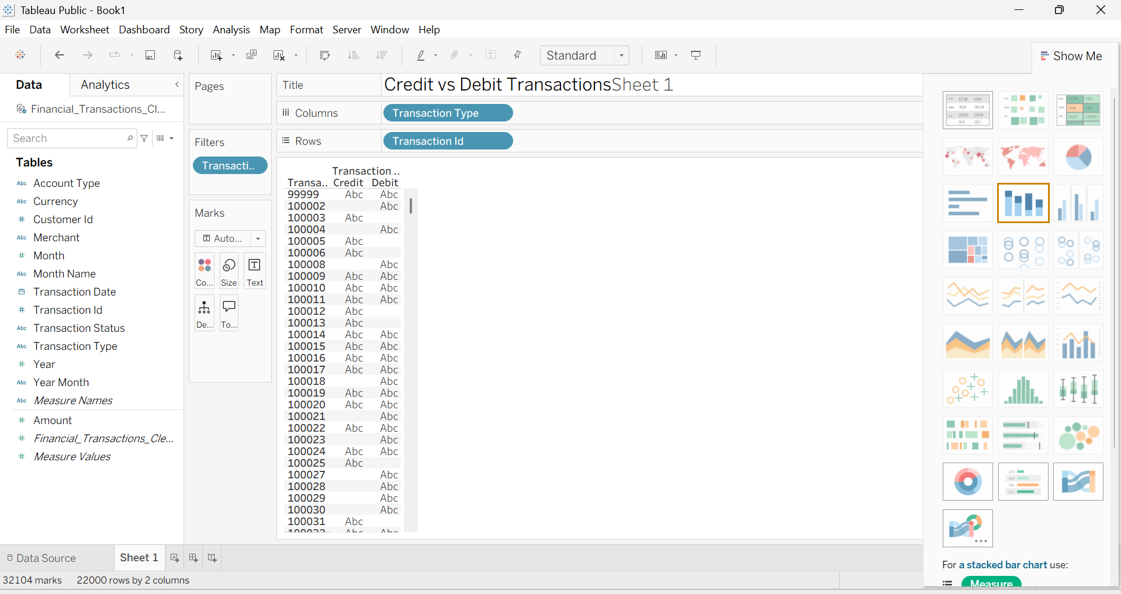
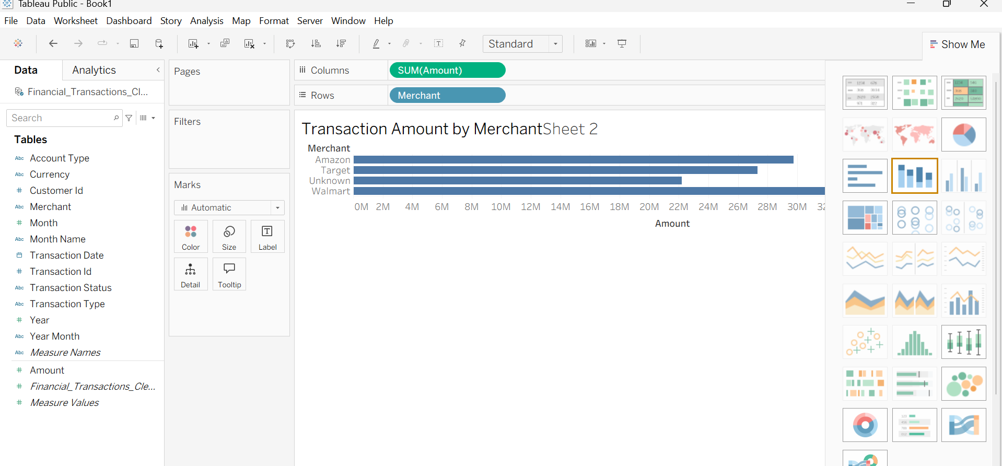
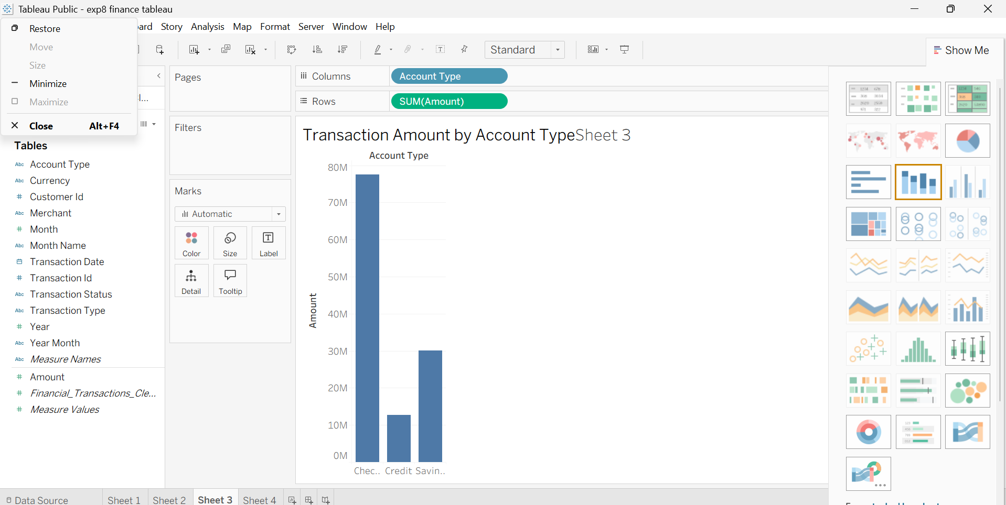
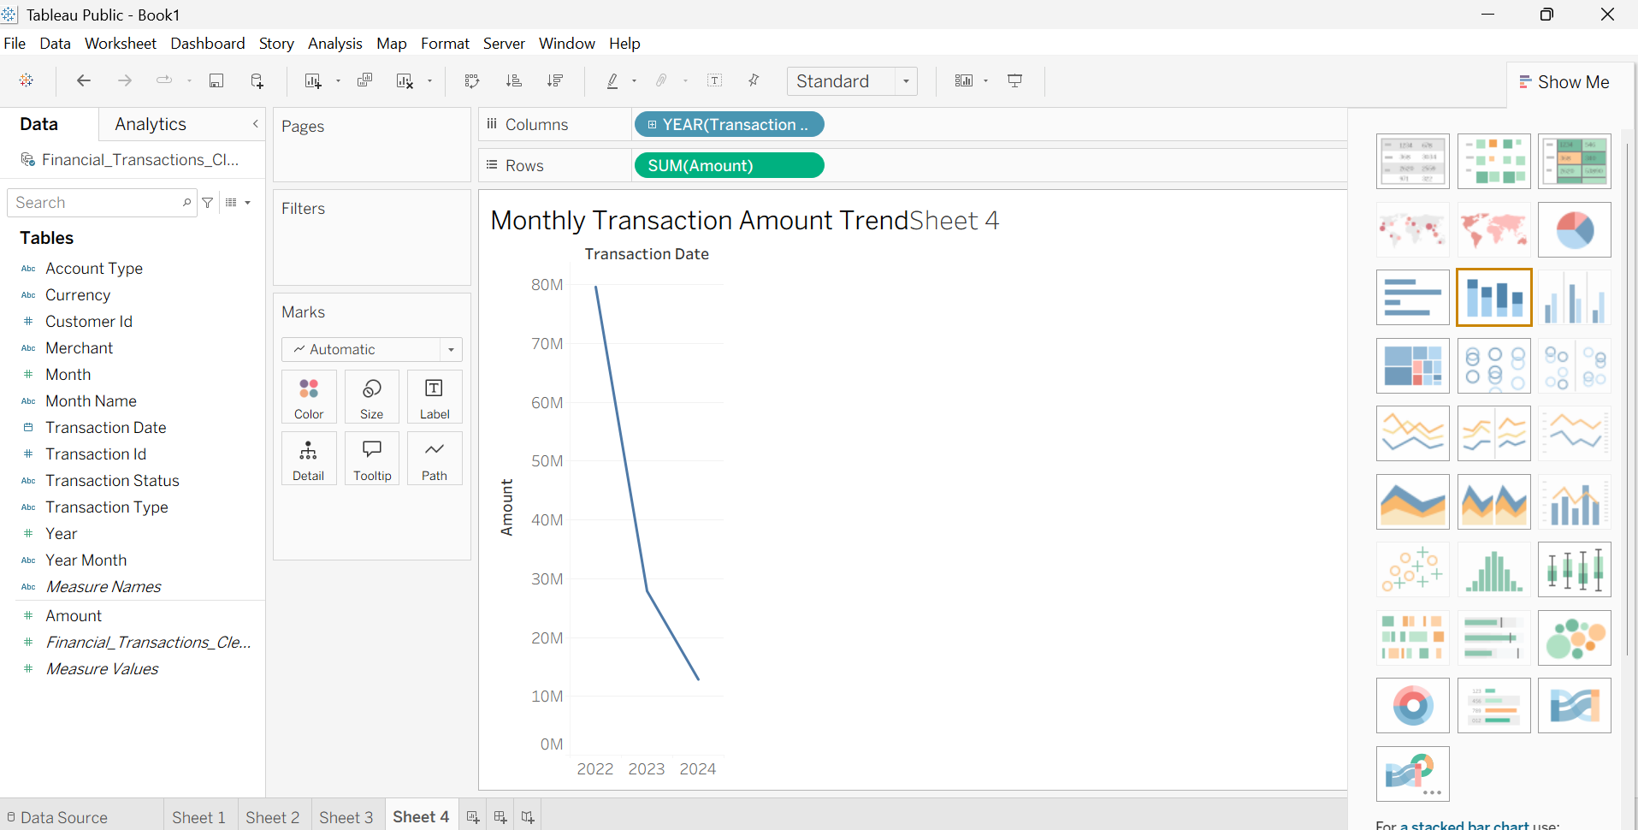
Result:

